
Recognise Record Respond
STOPSLEY BAPTIST CHURCH
SAFEGUARDING CHILDREN & ADULTS
▪ RECORDING FORM ▪ REFERRALS TO DPS OR SOCIAL SERVICES ▪

VERY IMPORTANT: If you consider the concern to be of an urgent nature, action should be taken
immediately and this recording form completed afterwards

Name |  | Date of Concern
Date of Birth/ Age (if known) |  | Name of Parent  (if applicable)
Your Name |  | Your Job Title
Concern:
Describe the event or observation (see reverse for body map) if the child/person has made a disclosure, record what the child/person said, using their own words on a piece of paper and attach to this form.
Impact: Is there any identifiable impact on the child/person, i.e. their physical or emotional wellbeing?
1.

2.

3.
Now take this form to the Ministry Leader, Designated Person for Safeguarding (DPS) or a Member of the Safeguarding Board.

Discuss the concern with the DPS and agree what actions to take.

They will keep this form on file and add a brief summary of the Concern, Impact etc
4.

5.
Agree when and how the actions will be reviewed:

Today’s date (If different from above):

PLEASE KEEP THIS FORM SAFE – DO NOT LEAVE IT FOR OTHERS TO SEE

Body Map

If concern is about a mark or injury, circle area of body where marks appear (body map), use Notes box below to describe the mark. In this type of event, seek advice immediately.

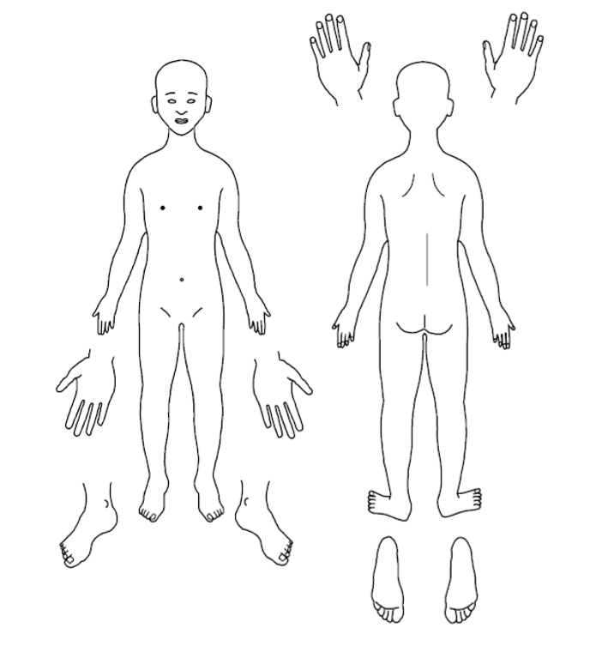
Notes

For Designated Person Use ONLY | When the actions have been completed and reviewed, make a note of the outcomes here:

A company limited by guarantee, registered in England and Wales
Company Number – 7605036
Registered Charity Number – 1150563
Registered Office – Stopsley Baptist Church, St. Thomas’s Road, Luton, LU2 7XP

